1. **50% off any 2 of our upcoming VPO Int’l Cuisine New Edition**.

(Our next 2 E-books will be released in June 2024)

You will have an option to choose from – 1. Home-Made Desserts E-book,

2. 100 Natural Healthy Teas E-book 3. Healthy Breakfast Recipe’s or 4. Party Recipe’s E-book.

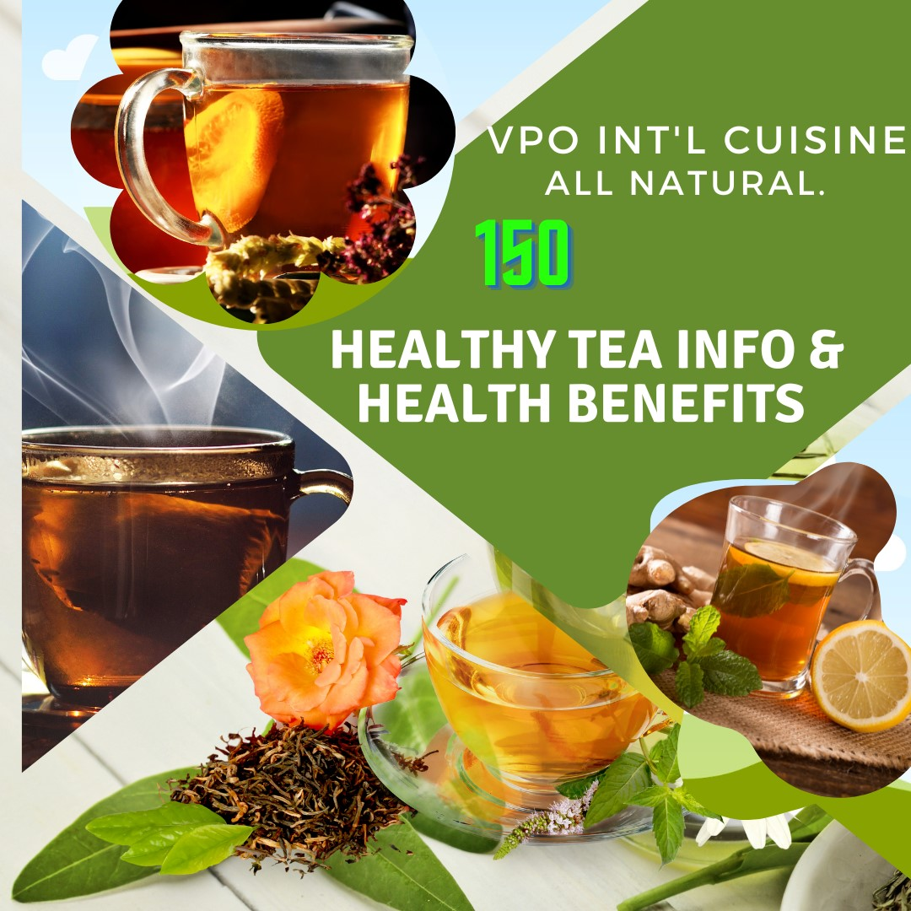

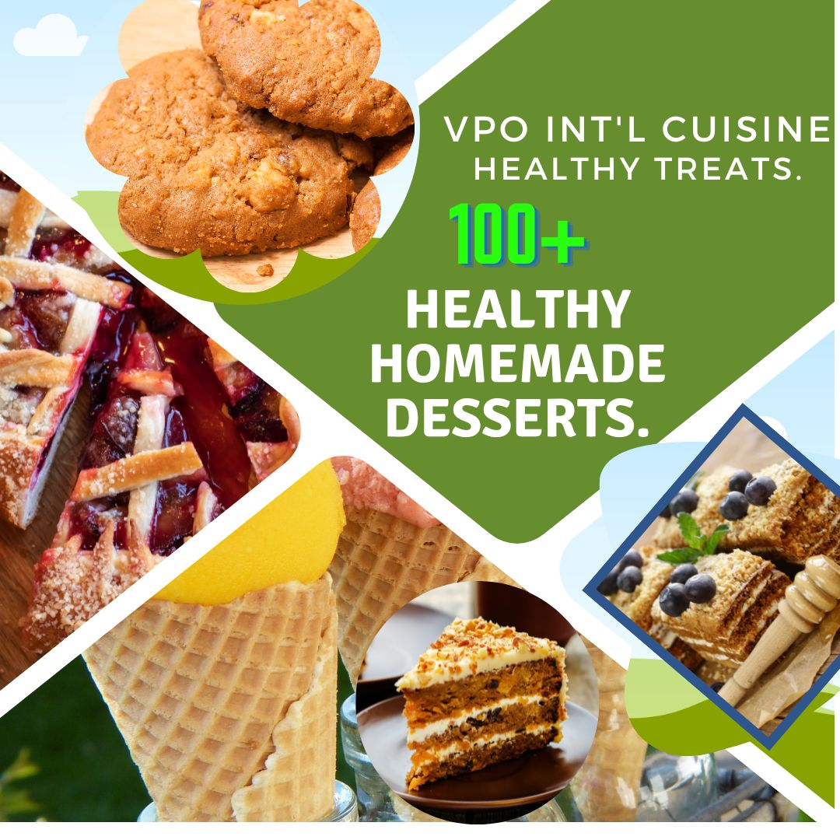

**100**

**30 New**

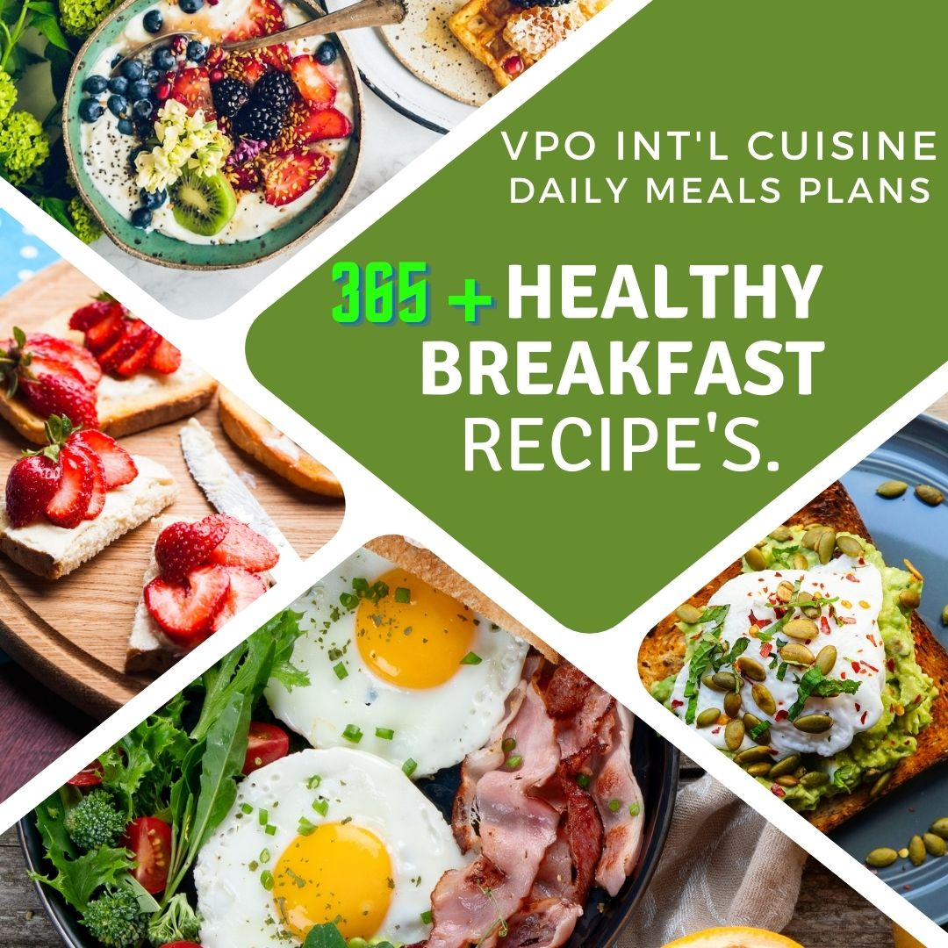

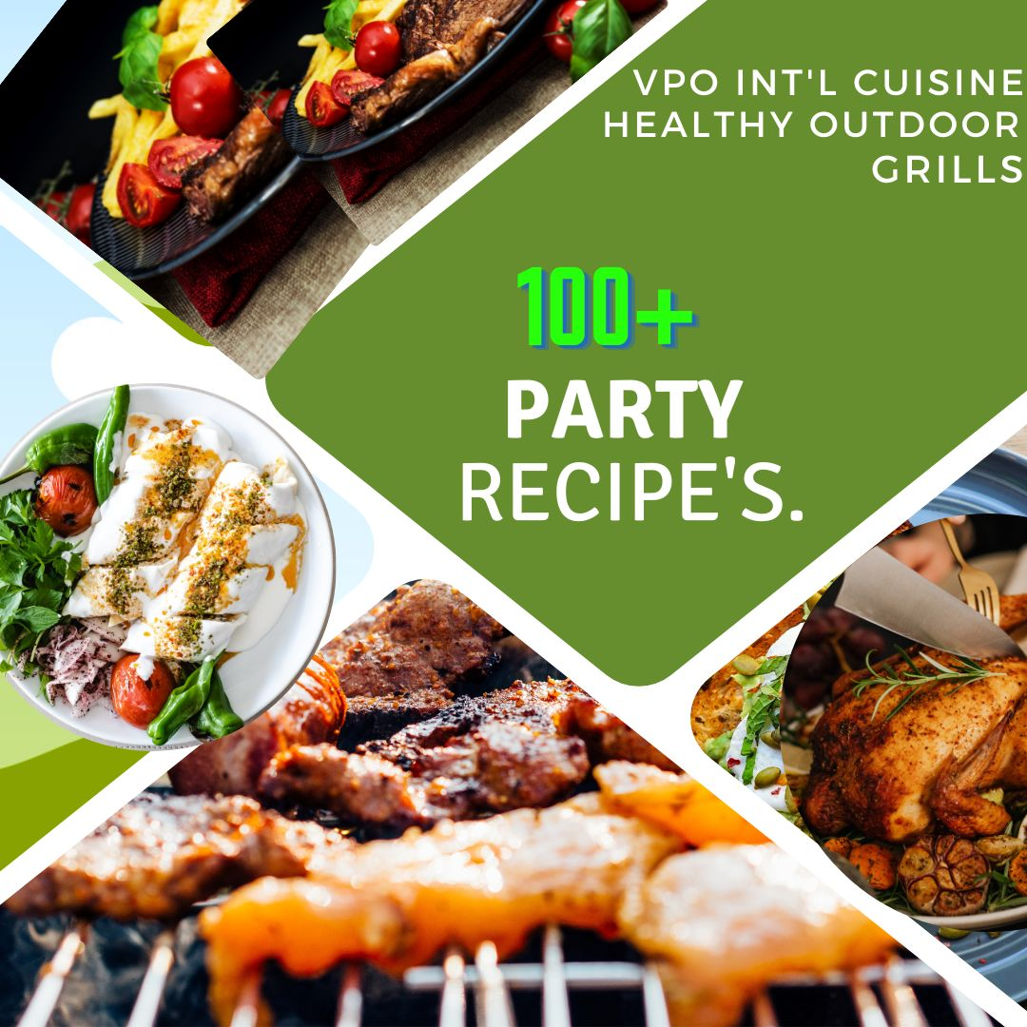

**30 New**

**30 New**